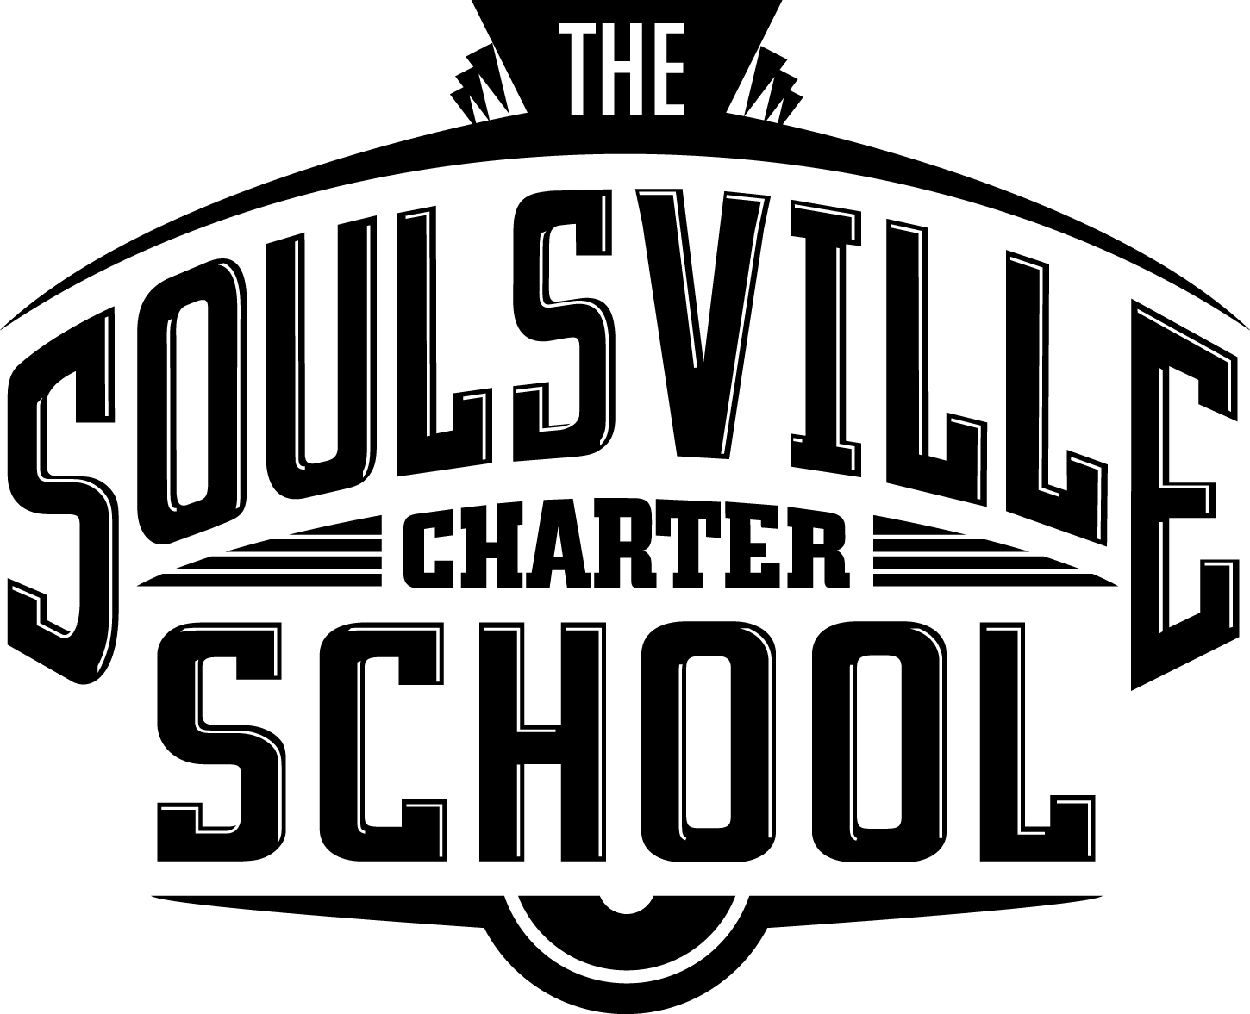
Administrative Board Meeting Agenda
TSCS Main Office Conference Room

- Call to Order

- Approval of Agenda

- Approval of Minutes of Previous Meeting

- Special Recognition/Presentation

- Reports

- Unfinished Board Business

- New Board Business

- Next Meeting

- Public Comments

- Adjournment

- Executive Session

